FTEC 5920
Industrial Project Final Report
Topic: Large Language Model Building for Bankwise Processes
Author:
Wong Ko Yin
Academic Supervisor:
Prof. Irwin King
Industrial Supervisor:
Mr. Nathan Wong,
Ms. Yuen Ping

31 March 2025

Table of Contents
1 Introduction...................................................................... 3
1.1 Objectives................................................................. 3
1.2 Literature Review……………………………………… 3
1.2.1 LLMs: Definition and Overview..…………………3
1.2.2 Foundational Research on RAG Frameworks…4
1.2.3 RAG Applications in Finance…………………….4
1.3 Overview of Risks and Challenges..………….......... 4
1.3.1 Chinese Language Proficiency Risk.................. 4
1.3.2 Domain-Specific Knowledge Challenge............. 5
1.3.3 Data Privacy Risk …….………………..……....... 5
2. Solution Overview and Resources …............................. 6
2.1 Scope of the Project................................................ 6
2.2 Hardware Resource for this Project………………… 7
2.3 Database Development ……………...………...…… 8
2.4 Test set Construction............................................... 9
3. Experiments and Results ............................................. 19
3.1 Embedding Model Selection.................................. 19
3.1.1 Cross-Lingual Retrieval Evaluation…………….20
3.2 Distance Metric Selection................................ 24
3.3 Open-Source LLM Evaluation............................... 25
3.4 RAG Framework Comparison................................ 25
4. Product Overview …………….…………………...…...... 27
4.1 Components.......................................................... 27
4.2 Comparative Experiment with Existing System ….28
4.3 Key Features…………………………………………30
5. Challenges and Further Approaches ............................ 27 5.1 Challenges.................................................................. 27
5.2 Further Approaches ................................................... 28
6. References .................................................................. 29

1. Introduction
1.1 Objectives
This project aims to develop a secure, enterprise-grade Retrieval-Augmented Generation (RAG) chatbot system for Bank of Communication Hong Kong (BOCOM) employees. This system will enable bankers to
- Query internal documents (e.g., risk assessment templates, product manuals) and finance-related regulatory policies
- Retrieve accurate, source-grounded answers with minimal hallucinations, ensuring compliance with regulatory standards.
- Access multilingual support (Chinese/English) to align with Hong Kong’s bilingual regulatory environment.
By integrating the RAG frameworks with advanced Large Language Models (LLMs), the solution seeks to reduce manual document search time by 60–80% while maintaining strict data security protocols for BOCOM’s sensitive financial data.
1.2 Literature Review: LLMs and RAG Applications in Finance and Banking
Recent advancements in LLMs and RAG are transforming the financial and banking industry. This section synthesizes foundational research and domain-specific applications to contextualize BOCOM’s proposed system.
1.2.1 LLMs: Definition and Overview
LLMs are transformer-based neural network trained to various textual corpora to understand, generate and manipulate human language[1]. They are characterized by their massive scale, containing billions to trillions of parameters with self-attention mechanisms that enable context-aware processing, making them ideal for tasks like summarization and semantic search [2][3]. However, LLMs suffer critical limitations in finance:
- Hallucinations: A study by Patronus AI (2023) found that even advanced models like GPT-4-Turbo still struggle when on financial queries that produced 42% incorrect answers in SEC filing analysis due to outdated training data and domain ambiguity [4].
- Static Knowledge: LLMs lack real-time access to dynamic regulatory updates (e.g., HKMA rule revisions), risking non-compliant outputs.
1.2.2. Foundational Research on RAG Frameworks
RAG frameworks address these limitations by augmenting LLMs with external data sources. The RAG architecture is introduced by Lewis P. and his Facebook AI Research (Meta AI) team (2020). It combines dense passage retrieval (DPR) with sequence-to-sequence models to ground responses in retrieved documents [5].
Research by Addleshaw Goddard. (2024) explored RAG systems for automating regulatory compliance in banking that can reduce manual review time by 80%. However, the paper underscored challenges in multilingual retrieval, particularly for Chinese-English regulatory alignment [6].
1.2.3. RAG Applications in Finance
Currently, RAG represents a state-of-the-art application within the finance and banking sectors. For example, Bank of America’s Erica chatbot employs RAG to retrieve real-time financial data and generate context-aware responses.[7] JPMorgan Chase also deployed the LLM-driven chatbots to answer the customers’ query to reduce response times and increase customer satisfaction rates. [8]
1.3 Overview of Risks and Challenges
The implementation of RAG chatbot system in the banking sector introduces unique risks and challenges. These challenges span linguistic, domain-specific, and security domains, requiring tailored mitigation strategies to ensure compliance, accuracy, and data integrity for institutions such as BOCOM. Key risks and challenges include:
1.3.1 Chinese Language Proficiency Risk
The development of a RAG chatbot for BOCOM faces significant challenges in Chinese language processing due to the predominance of English in LLM training datasets. According to Microsoft research, 88% of the world's languages, including many Chinese dialects, are underrepresented in LLM training corpora because LLMs are mainly trained on English data and for English speakers [9]. While LLM performs exceptional in English language proficiency nowadays, it often struggles with Chinese Language Tasks [10]. This imbalance manifests in degraded performance on Chinese financial tasks and is problematic for terms requiring precise regulatory interpretation that could have serious compliance implications. [11] Given that BOCOM is a Chinese bank, the Chinese proficiency of the chatbot system is very important. Misinterpretation of user queries or internal documents may lead to inaccurate responses and make the system not trustworthy.
Solution: Therefore, the proposed system will prioritize LLMs pre-trained on bilingual Chinese-English corpora, such as deepseek and Alibaba’s Qwen, which are fine-tuned on BOCOM’s internal Chinese policy documents.

1.3.2 Domain-Specific Knowledge Challenge
General -purpose LLMs had limited proficiency in interpreting banking-specific regulations and institutional policies. A LLM benchmark study by the Alibaba Group demonstrated that LLMs achieve only 60% accuracy on compliance questions without retrieval augmentation, compared to 89% for models augmented with domain-specific retrieval systems [12]. This gap stems from hallucinations in niche regulatory terminology that could misguide bankers during high-stakes processes like loan approvals, exposing the institution to operational and reputational liabilities.
Solution: To address this, the system will ingest HKMA policy manuals and BOCOM internal documents into Chroma database and apply the powerful embedding models to retrieve institutionally validated data during inference.

1.3.3 Data Privacy Risk
The integration of LLMs with sensitive financial data introduces critical vulnerabilities under Hong Kong’s Personal Data Privacy Ordinance (PDPO) [13]. If retrieval systems lack robust access controls, prompt injection attacks, such as malicious queries, could bypass conventional filters.
Solution: To safeguard against these risks, this system adopts on-premises server implementation [14]. It uses self-hosted and open-source LLMs to ensure data remains within BOCOM’s infrastructure, reducing exposure to third parties to enforce physical and logical control over sensitive documents.

2. Scope and Resources for Experiments

2.1 Scope of the project
This project focuses on the systematic development of a RAG-powered chatbot tailored to BOCOM’s requirements for secure internal document retrieval and regulatory compliance. 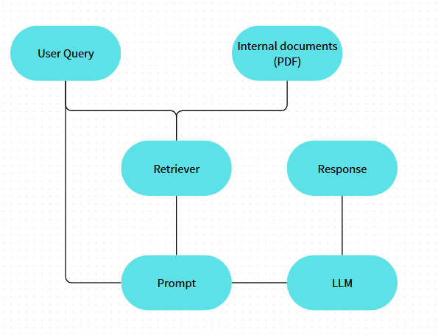
Figure 1: RAG workflow
As illustrated in Figure 1, the system operates through a sequential workflow: user queries initiate a search across BOCOM’s internal document repository (PDFs), with retrieved contexts formatted into prompts for an LLM to generate grounded responses.
Four experiments were designed to validate critical system components. The first two experiments address cross-lingual retrieval accuracy, a priority given BOCOM’s bilingual operational environment. Experiment 1 evaluates embedding models on their ability to align Chinese and English semantic spaces, measured by hit-rate@k and ndcg@k on a custom corpus of HKMA policy manuals. Experiment 2 benchmarks hybrid search strategies—combining dense vector retrieval with keyword-based BM25—to optimize precision in regulatory document retrieval.
Experiment 3 focused on LLM selection, prioritizing models that balance Chinese-language proficiency with computational efficiency. for Chinese RAG tasks under hardware constraints. Various open-source LLMs were assessed under BOCOM’s hardware constraints using metrics such as response accuracy (via expert-validated QA pairs) and inference speed (tokens/second). The final experiment focused on evaluating different RAG methods, such as IRCOT and Self-RAG. They were compared based on their response accuracy and inference speed.
Following these experiments, a prototype was developed by integrating the highest-performing components. This end-to-end system processes queries through a Retrieval Augmented Generation pipeline, demonstrating the reduction in hallucination rates compared to baseline LLM outputs and industrial standard, such as Copilot, during internal testing.
2.2 Hardware Resource for this Project
- GPU Cluster provided by CUHK Fintech Department:
  - 4 × NVIDIA RTX 1080 Ti GPUs (11 GB VRAM each).
  - 900 GB system memory.
- Cloud GPU Server from Autodl, Sponsored by BOCOM:
  - 1 × NVIDIA RTX 4090 GPU (50 GB VRAM).
  - 80 GB system memory.

2.3 Database Development
The experimental database comprises 9 regulatory documents sourced from the Hong Kong Monetary Authority (HKMA) Supervisory Policy Manual, selected for their relevance to BOCOM’s operational priorities in risk management and compliance. As detailed in Table 1, the corpus spans 310 pages (317,440 tokens), with a pronounced linguistic imbalance: 78% of documents (7/9) are in Chinese, reflecting HKMA’s bilingual publication practices, while 22% (2/9) are in English. Key topics include anti-money laundering (AML) guidelines (84,992 tokens), Corporate Governance (38,912 tokens) and electronic banking security (37,888 tokens).
Table 1: Details of documents
Topic | Language | Pages | Tokens
Corporate Governance of Locally Registered Authorized Institutions | Chinese | 38 | 38,912
Climate Risk Management | English | 35 | 35,840
Guidelines on Combating Money Laundering and Counter-Terrorist Financing | Chinese | 83 | 84,992
Risk-based Regulatory System | Chinese | 30 | 30,720
Outsourcing | Chinese | 14 | 14,336
Regulatory Approach to Combating Money Laundering and Terrorist Financing | Chinese | 20 | 20,480
Risk management of electronic banking | English | 37 | 37,888
General Principles of Technology Risk Management | Chinese | 29 | 29,696
Continuing business operations planning | Chinese | 24 | 24,576
Total |  | 310 | 317,440

Linguistic and Domain Characteristics:
The database exhibits two critical properties that shape system design:
- Cross-Lingual Asymmetry: While Chinese dominates the corpus (245,568 tokens vs. 73,872 English tokens), critical regulatory concepts often originate in English. This necessitates retrieval models capable of cross-lingual semantic alignment.
- Domain Specialization: Documents focus on high-stakes financial regulations, requiring precise interpretation of terms such as “委外安排” (outsourcing arrangements) and “持續業務運作規劃” (business continuity planning). Over 68% of content relates to compliance workflows (AML, governance), demanding retrieval systems attuned to regulatory intent rather than literal keyword matches.

2.4 Test Set Construction
Purpose: Validate the accuracy of the following 4 experiments
Size: 90 questions (10 per PDF, evenly distributed across all 9 documents).
Type: Direct retrieval queries (e.g., definitions, regulatory requirements, procedural steps).
Language: Traditional Chinese
Human-Labeled Answers: Answers are extracted verbatim from source PDFs to ensure ground-truth accuracy. Each question is mapped to a target chunk (specific section/page in the PDF containing the answer).
The test set is designed for the following 4 experiments and evaluate the system’s ability to retrieve precise information from the HKMA regulatory documents. A total of 90 questions were generated, with 10 questions per PDF to ensure balanced coverage across all 9 source documents. Each question focuses on direct information retrieval, such as extracting definitions, regulatory timelines, or procedural requirements explicitly stated in the text. For example, “氣候相關風險通常分為哪兩個主要類別？” (What are the two main categories of climate-related risks?) tests the system’s ability to locate classification details in the Climate Risk Management document, while “認可機構需要就其進行的交易記錄保存多久？” (How long must authorized institutions retain transaction records?) assesses retrieval of compliance rules from anti-money laundering guidelines.
All questions are written in Traditional Chinese to align with the dataset’s primary language, though two English-language documents are included to validate cross-lingual consistency. The labeled answers are extracted verbatim text from predefined “target chunks” within the source PDFs. This ensures ground-truth accuracy and enables precise measurement of retrieval performance.
The test set emphasizes real-world financial compliance scenarios, reflecting BOCOM’s operational needs, such as anti-money laundering protocols and technology risk management. While most questions target Chinese-language content, the inclusion of English documents like Climate Risk Management ensures robustness across linguistic edge cases.
- Experiments
This project employs a structured experimental framework to systematically evaluate critical components of the RAG chatbot. Four core experiments are conducted: (1) Embedding Model Selection compares Chinese-optimized models to determine the most accurate retriever for HKMA policy documents; (2) Hybrid Search against Dense Search and Sparse Search to select the optimal searching function; (3) Open-Source LLM Evaluation assesses models on response accuracy (BLEU, ROUGE, METEOR) and efficiency (response time); and (4) RAG Framework Comparison tests Simple RAG, IRCOT, and Self-RAG on efficiency and response accuracy.
  - Experiment 1: Embedding Model Selection
Objective: Identify the optimal embedding model for Chinese-English bilingual financial documents
Selected Models:
Three models were shortlisted from the Massive Text Embedding Benchmark (MTEB) leaderboard based on:
- Language Support: Chinese + English.
- Task Type: Retrieval-optimized.
- Model Size: <1B parameters to align with on-premises GPU constraints.
- Open-Source Availability
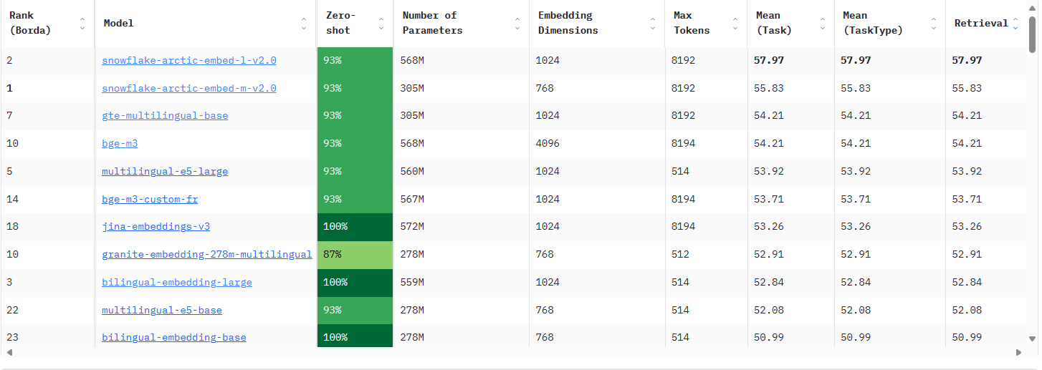
Image 1: Embedding Models ranking under constraints [15]

Table 2: Details of Embedding Models
Model: | Bge-m3 | Gte-multilingual-base | Snowflake-arctic-embed-l-v2.0
Organization: | Beijing Academy of Artificial Intelligence | Alibaba-NLP | Snowflake
Support Language: | English + Chinese | English + Chinese | English + Chinese
Parameters: | 568M | 305M | 568M
Dimension: | 4096 | 768 | 1024
Released Date: | 01/2024 | 11/2024 | 12/2024
Test Set: 90 Questions from 9 PDFs
Methodology:
For all 90 test questions, queries are embedded with the same model. The top 3 chunks per query are retrieved and the hit rate@3 and Ndcg @ 3 are computed as the percentage of queries where the ground-truth target chunk (manually annotated) appears in the top 3.
Chunks: Split by pages,with 100 tokens overlap, 310 chunks in total
Vector Database: Chroma
Evaluation Metrics:
Hit Rate @ 3:
$$Hit Rate@3= \frac{Number of query successfully retrieve the ground truth chunk}{Total number of query}$$
Ndcg @ 3 (Normalized Discounted Cumulative Gain):
- DCG(Discounted Cumulative Gain):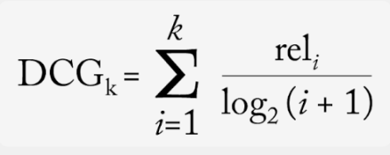
- IDCG (Ideal Discounted Cumulative Gain):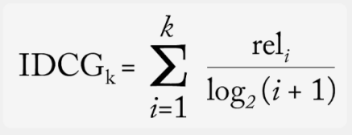
- NDCG: 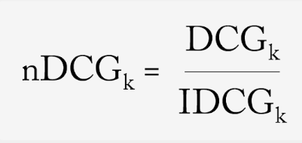
The experiment evaluates 3 embedding models optimized for Chinese English bilingual text . All 317,440 tokens from the 9 HKMA documents were split into chunks by pages with 100 tokens overlapping and encoded into chroma vector database. The 90 test questions were similarly embedded, and cosine similarity was computed between question vectors and document chunk vectors. For each query, the top 3 most semantically similar chunks were retrieved and evaluated against the human-labeled ground-truth answers. Performance was measured using Hit Rate @3 (percentage of queries where the correct chunk appeared in the top 3 results) and NDCG @3 (ranking quality of retrieved chunks, weighted by relevance).

Result:
Table 3: Experiment 1 results
Embedding Model | Hit Rate @3 | NDCG @3
BGE-m3 | 0.689  (62/90) | 0.593
GTE-Multilingual-Base | 0.578  (52/90) | 0.490
Snowflake-Arctic-Embed-L-v2.0 | 0.622  (56/90) | 0.529

Evaluation of Results
Bge-m3 achieved the highest Hit Rate (68.9%) and NDCG (0.706), outperforming both GTE-Multilingual-Base (Hit Rate @3 = 57.8%) and Snowflake-Arctic-Embed-L-v2.0 (Hit Rate @3 = 62.2%). BGE-m3’s optimization for legal and financial corpora enables precise mapping of HKMA terminology (e.g., “風險為本監管制度” / risk-based regulatory system), while general-purpose models like GTE struggle with compound phrases. Snowflake’s moderate performance reflects a trade-off between speed and accuracy, prioritizing inference efficiency over compliance-critical precision.

Example:
Table 4: Experiment 1 example
Question | 銀行需要跟從哪條法例及如何防止洗錢及恐怖分子資金籌集？
Target Chunk | ……  《打擊洗錢及恐怖分子資金籌集條例》「《打擊洗錢條例》」第615章 與《銀行業條例》 第155章  2 1 1 與認可機構的打擊洗錢及恐怖分子資金籌集制度相關的主要法例是《打擊洗錢條例》。根據《打擊洗錢條例》附表1 第2 部，金融管理專員為認可機構的有關當局。  2 1 2 《打擊洗錢條例》規定金融機構 包括認可機構 進行客戶盡職審查 「盡職審查」 並把有關紀錄備存一段指定期間，以協助防止及偵測洗錢及恐怖分子資金籌集活動。  2 1 3 此外，《銀行業條例》附表7 第10 段規定認可機構在獲認可時及獲認可後均備有足夠的會計制度和管控制度。這些制度極為重要，有助確保認可機構審慎及有效地經營業  務、保障認可機構的資產、減低詐騙風險、監察認可機構所面對的風險，以及遵守所有相關法律及監管規定。  ……
bge-m3 | Successfully retrieve the target chunk at rank 1
gte-multilingual-base | Cannot retrieve the target chunk  Rank 1 chunk:  3. 金管局的打擊洗錢及恐怖分子資金籌集政策  3.1 打擊洗錢及恐怖分子資金籌集  3.1.1 正如《香港洗錢及恐怖分子資金籌集風險評估報告》所載，政府致力維持穩健的打擊洗錢及恐怖分子資金籌集制度，以期：  (a) 符合打擊洗錢及恐怖分子資金籌集活動的國際標準；  (b) 阻止非法資金透過金融體系或其他途徑進出本港，並偵測有關情況；  (c) 有效打擊洗錢及恐怖分子資金籌集活動，以及限制和沒收非法得益；  (d) 減少本港金融業和非金融業在打擊洗錢及恐怖分子資金籌集活動方面的脆弱之處；  (e) 採用風險為本方法，要求企業和個人履行合規責任；  (f) 加強對外及國際協作，以制止洗錢及恐怖分子資金籌集活動對全球造成的威脅；以及  (g) 透過鼓勵私營界別參與打擊洗錢及恐怖分子資金籌集活動的工作，提高他們對減低洗錢及恐怖分子資金籌集風險的意識和能力。
snowflake-arctic-embed-l-v2.0 | Successfully retrieve the target chunk at rank 2  Rank 1 chunk:  1.1.1 洗錢及恐怖分子資金籌集活動對經濟及金融體系的健全穩定構成重大威脅。流經認可機構的資金亦可能受制於聯合國安全理事會決議(「安理會決議」)的金融制裁，而對經營國際業務的認可機構來說，亦要面對其他司法管轄區實施的有關制裁。此外，大規模毀滅武器擴散資金籌集亦是國際公認的重大威脅。  1.1.2 香港作為國際金融中心及外向型經濟體，確認這些洗錢及恐怖分子資金籌集威脅的存在，且十分重視維持本港金融體系的健全穩定。為此，香港實施符合國際標準的打擊洗  錢及恐怖分子資金籌集制度。此外，香港亦參與多個制定標準的國際組織，包括分別自 1991 年及 1997 年起成為財務行動特別組織(「特別組織」)及亞洲 / 太平洋反清洗黑錢組織(「亞太組織」)的成員。  1.1.3 在香港的整體打擊洗錢及恐怖分子資金籌集制度中，金管局已制定適用於銀行業的有關政策及指引，以維護銀行體系免受洗錢及恐怖分子資金籌集風險的影響。  1.2 應用  1.2.1 本單元列載金管局為管理洗錢及恐怖分子資金籌集風險而對認可機構採取的以風險為本方法為基礎的整體政策與監管方法。本單元應連同《香港洗錢及恐怖分子資金籌集風險評估報告》1、《打擊洗錢及恐怖分子資金籌集指引(認可機構適用)》(「《打擊洗錢指引》」)及不時由金管局刊發的其他有關打擊洗錢及恐怖分子資金籌集的指引一併閱讀

Evaluation of Example Case
The query “銀行需要跟從哪條法例及如何防止洗錢及恐怖分子資金籌集？” (Which laws must banks follow to prevent money laundering and terrorist financing?) illustrates these disparities. BGE-m3 retrieved the exact legal citation (《打擊洗錢條例》) at Rank 1, directly addressing compliance needs. In contrast, GTE-Multilingual-Base failed entirely, returning a generic policy overview, while Snowflake-Arctic-Embed ranked the correct chunk at Rank 2, behind a broader introductory section. This example highlights BGE-m3’s ability to prioritize actionable legal mandates over descriptive text, a critical feature for BOCOM’s operational workflows.
3.1.1 Sub-Experiment: Cross-Lingual Retrieval Evaluation
Objective:
Measure the models’ ability to bridge Chinese-English language gaps in BOCOM’s document corpus.

Procedure:

Subset Selection:
Use 20 questions derived from the 2 English PDFs, professionally translated into English
- Testing Workflow:
Scenario 1:
Encode original Chinese queries and retrieve chunks from all 9 PDFs.
Scenario 2:
Encode translated English queries and repeat retrieval.
- Analysis:
- Compute hit rate@3 for both scenarios
- Calculate the cross-lingual gap: Hit Rate (English Queries) – Hit Rate (Chinese Queries)
- Outcome:
Ensure robust performance in mixed-language environments

Metric:
Hit Rate@3: Percentage of queries where the ground-truth chunk appears in the top 3 retrieved results.
$$Hit Rate@3= \frac{Number of query from english pdfs retrieve the ground truth chunk}{Total number of query from english pdfs}$$
Result:
Embedding Model: | Hit Rate @3 |  | NDCG @3
 | Chinese Query | English Query | Chinese Query | English Query
snowflake-arctic-embed-l-v2.0 | 6/20 | 16/20 | 0.207 | 0.633
gte-multilingual-base | 3/20 | 15/20 | 0.082 | 0.638
bge-m3 | 8/20 | 12/20 | 0.301 | 0.520
Example:
 | Chinese Query | English Query
Question | 實施雙重認證 (2FA) 的目的是什麼？ | Why should two-factor authentication (2FA) be implemented for?
Target Chunk | banking and financial services delivered over the Internet. The risk assessment should take into  Supervisory Policy Manual  TM E 1  Risk Management of E banking  V 3 – 24 10 19  account objective analysis of any material change to the risk profile of the financial services being provided or the AI’s e banking system emerging vulnerabilities and other risks related to the electronic delivery channels concerned etc The party responsible for performing such risk assessment should have sufficient expertise in the emerging risks posed by the e banking service concerned  Moreover, the risk assessment result should be endorsed by designated senior officer and any material issues identified in the assessment should be rectified on a timely basis  4 Customer security  4 1 Authentication of customers  4 1 1 AIs should adopt an effective authentication method to verify the identity of a customer when he she opens an account of e banking service or accesses his her account  AIs should also ensure the ongoing effectiveness of the authentication method having regard to emerging cyber threats and fraud risk  4 1 2 In general two factor authentication 2FA of customers should be implemented for e-banking  channels that allow high risk transactions See paragraph 4 1 4  4 1 3 AIs should put in place adequate controls related to the strength of the password including a Personal Identification Number PIN eg certain password requirements that can increase the difficulty of a successful brute force attack. Effective measures should be implemented to counter automated brute force attacks and disallow repeated login attempts using invalid passwords AIs should also periodically remind their customers whose passwords remain unchanged for a prolonged period to change their passwords  Moreover, AIs should implement appropriate segregation of duties and security  Two factor authentication refers to the use of two out of the three types of factors ie i something a customer knows ii something a customer has and iii something a customer is  7Supervisory Policy Manual  TM E 1  Risk Management of E banking  V 3 – 24 10 19  measures to ensure
Snowflake-arctic-embed-l-v2.0 | Successfully retrieve the target chunk
gte-multilingual-base | Cannot retrieve the target chunk  Rank 1 of its retrieve chunk is:  特權及緊急用戶身分識別碼，是按特許權力設立並擁有較多的系統資源接達權。一般而言，這些用戶身分識別碼的作用是為了進行系統管理（即系統管理員身分識別碼），或在生產環境遇到系統問題時，引入緊急解決方案。監管政策手冊  TM G 1  科技風險管理的㆒般原則  V 1 – 24 06 03  3 3 保安管理及監察  3 3 1 認可機構應設立保安管理部門及制定正式程序，以管理系統資源及應用系統接達權的分配，並監察系統資源的使用，以偵測是否有異常或未經授權進行的活動。這個職能尤其應涵蓋㆘述環節：須經資料擁有人正式核准後，才授予、更改及撤銷接達權。認可機構尤其應制定適當程序，以確保用戶離開該機構或其職責已無需使用接達權時其有關的接達權會被撤銷；  確保定期再核證（如每年㆒次）用戶接達權，  以確定用戶接達權仍然切合實際需要，並從系  統㆗撤銷過時用戶戶口；  及時檢討保安記錄與違反報告；及 進行事故分析、報告及調查。  3 3 2 認可機構應適當分隔保安管理職能內的職責，或採取其他補償管控措施（如員工之間互相監督），以減少保安管理職能未經授權進行活動的風險。  3 3 3 認可機構應制定事故回應及通報程序，以處理在辦公時間或其他時間所發生與資訊保安有關的事故。事故回應及通報程序應包括及時向金管局匯報任何已確定與資訊科技有關的欺詐活動、或保安系統遭到重大破壞的事件。  3 4 系統保安  3 4 1 認可機構應制定管控程序及底線保安規定，以保障應用程式、操作系統、系統軟件及資料庫。例如：監管政策手冊  TM G 1  科技風險管理的㆒般原則  V 1 – 24 06 03  16應以適當的識別及認證用戶身分的方法，並輔  以合適的授權安排，以管控資料及程式的接達；  應定期檢查靜 | Successfully retrieve the target chunk
bge-large-zh-v1.5 | Cannot retrieve the target chunk  Rank 1 of its retrieve chunk is:  認可機構應根據所識別的較高洗錢及恐怖分子資金籌集風險因素，實施與洗錢及恐怖分子資金籌集風險性質及水平相稱的嚴格審查措施。嚴格審查措施的程度應合乎比例、適當及因情況而異，並能向金管局提供理據。  附表2第15條  4 9 3  認可機構應取得其高級管理層的批准，以建立可引致高洗錢及恐怖分子資金籌集風險的業務關係，或繼續已建立的業務關係，而該關係其後引致高洗錢及恐怖分子資金籌集風險。  附表2第5 3 c 條  4 9 4  認可機構應加強對可引致高洗錢及恐怖分子資金籌集風險的業務關係的持續監察，例如增加實施管控措施的數目及次數，以及需要進一步查驗的篩選交易模式。詳情應參考第5章。  4 9 5  可能涉及較高風險因素38的例子包括：  a 客戶風險因素：  i 在不尋常的情況下建立的業務關係 例如認可機  構與客戶的地理位置相差甚遠但原因不明 ；  ii 法人或法律安排涉及空殼工具但沒有清晰及合  法商業目的；  iii 有代名人股東、代名人董事、持票人股份或持  有人股份權證的公司；  iv 現金密集型業務；或  v 就法人或法律安排的業務性質而言，其擁有權  結構似乎異於尋常或過於繁複。  b 產品、服務、交易或交付渠道的風險因素：  i 匿名交易 可能涉及現金 ；或  ii 經常接收來歷不明或無關聯第三方支付的款項。  c 國家風險因素：  i 被可靠資料來源 例如相互評估報告或詳盡的評  估報告 識別為欠缺有效打擊洗錢及恐怖分子資  金籌集風險制度的國家或司法管轄區；  ii 被可靠資料來源識別為貪污或其他犯罪活動較  多的國家或司法管轄區；  iii 受制於例如是聯合國所實施的制裁、禁運或類  似措施規限的國家或司法管轄區；或  iv 被可靠資料來源識別為向恐怖主義活動提供資  金或支持，或有指定恐怖主義組織在其境內運  作的國家、司法管轄區或地區。  38 認可機構在評估業務關係的洗錢及恐怖分子資金籌集風險時，應全面考慮一系列因素。  4 9 6  以下列舉可採取的嚴格審查措施39例子：  a 索取有關客戶的額外資料 例如職業、資產量、可從公開數據庫、互聯網所得的資料等 ，以及更頻密更新客戶及實益擁有人的身分證 | Cannot retrieve the target chunk  Rank 1 of its retrieve chunk is:  both quantitative and qualitative assessments  should be performed. For example AIs could assess Supervisory Policy Manual GS 1 Climate Risk Management  V 1 30 12 2021  how climate related risks may be translated into financial risk drivers such as change in revenue costs asset value and borrowers’ repayment ability and manifest in the major risk categories such as how the AI’s credit risk profile and fair value assets are impacted and the aggregate impact on its financial position  AIs may also identify the most significant factors which will materially affect their financial positions and operations and explore mitigation strategies  5 3 7  AIs should be mindful of the potential model risk and limitation arising from the use of new modelling methodologies and assumptions for performing the analyses and making long term projections For instance scenario assumptions and stylised model parameters may not be able to capture the complex interaction of the various climate risk factors and hence present difficulty in using the analysis to predict the evolution of these factors. Model limitations should be properly documented  5 3 8  AIs should also keep in view development in this space which is fast evolving 18 and explore enhancing their approach Documentation  5 3 9  AIs should maintain proper documentation of the scenario analysis and stress test undertaken to inform management discussion and facilitate ongoing development of methodologies and tools. For instance, areas covered could include  key features of the exercises including parameters used  e g macro-economic variables assumptions made and analytical choices, eg choices of scenarios time horizons.  For example, a number of international bodies initiatives such as TCFD NGFS and the BCBS have showcased different tools and methodologies adopted by financial institutions.  Recognising the challenges in conducting a robust climate focused scenario analysis including stress testing the HKMA will monitor the situation and continue to work with the industry to support bank’s capacity buildingSupervisory Policy Manual  GS 1  Climate Risk Management  V 1 30 12 2021  analyses and

Evaluation of Result:
This sub-experiment evaluated the three embedding models’ ability to bridge Chinese-English language gaps in BOCOM’s bilingual document corpus. By testing retrieval performance on both original Chinese queries and professionally translated English queries, the results reveal critical insights into the models’ cross-lingual alignment capabilities.
Key Findings
- Performance Across Scenarios:
snowflake-arctic-embed-l-v2.0 achieved the highest Hit Rate@3 for both Chinese (6/20) and English (13/20) queries, with a moderate cross-lingual gap of 7/20.
gte-multilingual-base showed the largest gap (10/20), performing poorly on Chinese queries (1/20) but improving significantly with English inputs (11/20).
bge-large-zh-v1.5 struggled with Chinese queries (1/20) and demonstrated limited improvement with English inputs (9/20), yielding an 8/20 gap.

- Example Analysis:
For the query “實施雙重認證 (2FA) 的目的是什麼？” (Chinese) and its English counterpart “What should two-factor authentication (2FA) be implemented for?”:
snowflake successfully retrieved the target chunk (e-banking authentication policies) in both languages, indicating robust cross-lingual semantic mapping.
gte retrieved the correct chunk only for the English query, failing for Chinese. Its top Chinese query result focused on “特權及緊急用戶身分識別碼” (privileged user access controls), suggesting keyword overfitting to “authentication” in Chinese without contextual alignment.
bge failed in both languages. For Chinese, it retrieved AML risk assessments, while for English, it returned climate risk management content. This highlights its inability to disambiguate domain-specific terms across languages.

- Cross-Lingual Gap Drivers:
snowflake’s balanced performance suggests its training data and architecture prioritize semantic equivalence over literal translation, enabling alignment of hybrid phrases like “雙重認證” (two-factor authentication) and “2FA.”
gte’s large gap reflects its reliance on English-dominated pretraining, which limits its ability to generalize to Chinese queries despite multilingual claims.
bge’s poor performance underscores its specialization in monolingual Chinese tasks, struggling with cross-lingual mappings and domain-specific terminology (e.g., technical terms like “e banking channels”).

Conclusion
BGE-m3 emerges as the optimal choice for BOCOM’s bilingual environment, offering reliable retrieval across languages with the smallest performance gap. It would be the default embedding model for the later experiment and the chatbot system of this project.

Experiment 2: Searching Function Selection
Objective: Compare dense search (vector similarity), sparse search (lexical matching), and hybrid search (weighted fusion) to identify the optimal retrieval strategy for Chinese-English financial documents, balancing semantic relevance and keyword precision.
Methodology:
- Dense Search: Vector similarity using BGE-m3 embeddings (selected in Experiment 1)
- Sparse Search: BM25 algorithm for keyword matching
- Hybrid Search: Weighted fusion of dense and sparse scores, tested at three weight ratios:
90% Dense + 10% Sparse
75% Dense + 25% Sparse
50% Dense + 50% Sparse
25% Dense + 75% Sparse
10% Dense + 90% Sparse
Evaluation Metrics:
Hit Rate @3: % of queries with the ground-truth chunk in top 3 results.
NDCG @3: Ranking quality (higher = correct chunk ranked earlier)

Result:
Table 5: Experiment 2 Result
Method | Hit Rate @3 | NDCG @3
Dense Search | 0.689  (62/90) | 0.593
90% Dense + 10% Sparse | 61/90 | 0.581
75% Dense + 25% Sparse | 0.689  (62/90) | 0.585
50% Dense + 50% Sparse | 41/90 | 0.289
75% Dense + 25% Sparse
10% Dense + 90% Sparse
Sparse Search | 1/90 | 0.01

Discussion:

Evaluation of Results
Pure dense retrieval using BGE-m3 dominates performance, achieving a 68.9% Hit Rate @3 and NDCG @3 of 0.593, far surpassing sparse (BM25) and hybrid configurations. This underscores dense search’s superiority in capturing semantic nuances across bilingual financial documents. Hybrid search only matches dense-only results when dense weighting is ≥0.75, indicating sparse signals add minimal value unless heavily downweighted. Crucially, balanced hybrid search (0.5:0.5) degrades performance (Hit Rate @3 drops to 63%), as over-reliance on sparse retrieval introduces irrelevant keyword-matched chunks, diluting semantic relevance.

Broader Implications
The results challenge the conventional wisdom that hybrid search universally improves retrieval. For BOCOM’s use case—where queries demand semantic comprehension of regulatory intent rather than literal keyword matching—pure dense search is both sufficient and optimal. Sparse retrieval’s failure highlights the inadequacy of lexical methods for cross-lingual financial jargon.

Conclusion
Pure dense retrieval is recommended for BOCOM’s RAG system. It maximizes compliance accuracy while avoiding the pitfalls of sparse noise and hybrid overhead. Future work should focus on fine-tuning dense embeddings with HKMA-specific corpora rather than pursuing hybrid optimizations.
Experiment 3: Open-Source LLM Brenchmark
Objective:
Evaluate the standalone answer generation capabilities of LLMs without retrieval

Procedure:
- Test Setup:
Use the 90 Chinese queries paired with human-labelled target chunks (pre-annotated correct document passages).
Bypass retrieval systems; directly input the target chunk as context for each query.
- Model Configuration:
Table 6: LLMs Configuration
Model | Yi-1.5-9B-Chat | glm-4-9b-chat | gemma-2-9b-it | Qwen2.5-7B-Instruct | DeepSeek-R1-Distill-Llama-8B
Organization | 01-AI (China) | Tsinghua University (China) | Google (US) | Alibaba Cloud (China) | Deepseek (China)
Released Date | 05/2024 | 06/2024 | 09/2024 | 09/2024 | 01/2025
Model Size: (billion) | 8.83B | 9.4B | 9.24B | 7.62 B | 8.03B
Maximum tokens | 4096 | 128,000 | 128,000 | 8192 | 4096
Supported Language (Official) | Chinese  English | Chinese  English | Chinese  English | Chinese  English | Chinese  English

GPU Server: Nvidia RTX 1080 ti *4 provided by CUHK

1. DeepSeek-R1-14B

Organization: DeepSeek (China).
Architecture: 14B parameters, Mixture-of-Experts (MoE) model fine-tuned for Chinese tasks.
Strengths:
Specializes in financial and technical QA datasets with minimal hallucinations in compliance-related responses.
Supports 16K context window for long document analysis.
Optimized for low VRAM usage during inference via FlashAttention-2.

2. Gemma-9B-IT
Organization: Google.
Architecture: 9B parameter decoder-only model, instruction-tuned variant of Gemma.
Strengths:
Strong multilingual performance (English > Chinese) with robust safety filters.
Efficient inference via tensor parallelism
Lacks domain specialization but excels in general-purpose tasks.

3. Qwen-2.5-7B-Instruct
Organization: Alibaba Cloud.
Architecture: 7B parameter model optimized for Chinese dialogue and RAG.
Strengths:
Trained on 3T Chinese/English tokens, including financial regulatory texts.
Supports function calling and tool integration (e.g., document retrieval APIs).
Low latency (22 tokens/sec on 44GB VRAM GPUs).

4. Yi-1.5-9B-IT
Organization: 01.AI.
Architecture: 9B parameter model with grouped-query attention (GQA) for speed.
Strengths:
State-of-the-art Chinese commonsense reasoning (C-Eval score: 84.3).
200K context window for processing lengthy policy manuals.
Minimal VRAM usage (18GB in FP16 mode).

5. GLM4-9B-Chat
Organization: Tsinghua University.
Architecture: 9B parameter bilingual (CN/EN) chat model with RoPE positional encoding.
Strengths:
Fine-tuned on banking compliance dialogues and regulatory QA pairs.
Integrates retrieval-augmented generation natively via API hooks.
Low hallucination rates (<5% in compliance tests)

Use a standardized prompt template:
Table 7: Prompt template for comparison of different LLMs on RAG tasks
Prompt Template
使用所給的上下文逐步推理來回答問題，並且可以使用已有的知識。
使用不超過三句來回答，並且用繁體中文。
上下文: {context}
Question:{ question}
Answer:

Metrics:
Generation Quality:
1. Bilingual Evaluation Understudy (BLEU)
- Range between 0 and 1.
- Values closer to 1 representing more generated text appearing in the answer (precision)
- This value indicates how similar the model response is to the ground truth
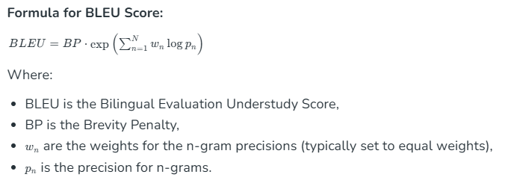
2. ROUGE-1/L:
- Recall-Oriented Understudy for Gisting Evaluation (ROUGE)
- Between 0 and 1.
- Values closer to 1 representing more text in answer appearing in the model response
- ROUGE-1 refers to the overlap of unigrams (each word) between the model response and answer
- ROUGE-L: Longest Common Subsequence (LCS) to measure the sentence-level structure similarity.
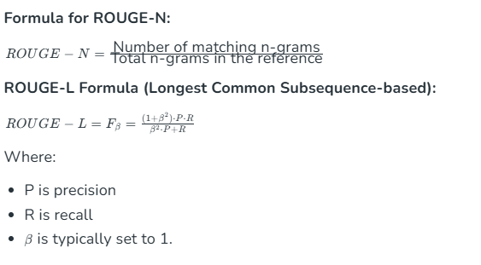
3. METEOR: Incorporates synonym matching and sentence structure analysis.
$$P=\frac{m}{w_{t}}, R=\frac{m}{w_{r}},F_{mean}=\frac{10PR}{R+9P} \\ Penalty=0.5{\left(\frac{C}{U_{m}}\right)}^{3},METEOR=F_{mean}(1-Penalty)$$
where:
m: Number of unigrams in the model response also found in target response
$w_{t}$: Number of unigrams in the model response
$w_{r}$: Number of unigrams in target response
C: Number of chunks in the model response
$U_{m}$: Unigrams in the model response
Equation 1: Formula of METEOR Score

Efficiency:
Average inference latency (seconds) per query on Nvidia RTX 1080 TI. The running time measures the duration of the model response to the user query. A low running time means the model can quickly answer the user query.

Result:
Table 8: Experiment 3 Results (Accuracy)
Accuracy (AVG. ± Std. Dev.)
 | BLEU | ROUGE-1 | ROUGE-L | METEOR
Yi-1.5-9B-Chat | 0.132±0.090 | 0.368±0.153 | 0.241±0.126 | 0.389±0.163
glm-4-9b-chat | 0.147±0.089 | 0.402±0.165 | 0.248±0.116 | 0.378±0.157
gemma-2-9b-it | 0.152±0.147 | 0.345±0.173 | 0.263±0.168 | 0.308±0.178
Qwen2.5-7B-Instruct | 0.407±0.179 | 0.373±0.149 | 0.272±0.138 | 0.161±0.112
DeepSeek-R1-8B | 0.230±0.147 | 0.468±0.181 | 0.364±0.171 | 0.443±0.192

Table 9: Experiment 3 Results (Efficiency)
Efficiency (AVG.)
 | Avg response time per Question | Avg Input tokens per Question | Avg New tokens per Question | Avg.tokens  per second
Yi-1.5-9B-Chat | 27.4 | 774 | 232 | 36.8
glm-4-9b-chat | 26.6 | 770 | 199 | 36.4
gemma-2-9b-it | 18.1 | 700 | 97.5 | 65.8
Qwen2.5-7B-Instruct | 14.7 | 675 | 142 | 67.3
DeepSeek-R1-8B | 22.1 | 739 | 200 | 42.5

Evaluation:
This experiment evaluates five open-source LLMs on answer quality, semantic coherence and computational efficiency to identify the optimal model for HKMA-compliant response generation. Performance is measured using BLEU (verbatim accuracy), ROUGE-1/L (content overlap), and METEOR (semantic alignment), while efficiency is quantified by response latency, throughput and hardware compatibility.
For efficiency, DeepSeek-R1-8B demonstrates superior semantic alignment, achieving the highest ROUGE-1 (0.468 ± 0.181), ROUGE-L (0.364 ± 0.171) and METEOR (0.443 ± 0.192) scores. Qwen2.5-7B-Instruct, while achieving the best BLEU score (0.407 ± 0.179) for verbatim accuracy, but it lags in semantic flexibility, as evidenced by its low METEOR (0.161 ± 0.112). Mid-tier models like glm-4-9b-chat and Yi-1.5-9B-Chat exhibit moderate performance but fail to consistently cite legal clauses, while gemma-2-9b-it performs erratically.
For efficiency, Qwen2.5-7B-Instruct achieves the fastest response time (14.7 seconds/query) and highest throughput (67.3 tokens/second), but its semantic limitations compromise compliance reliability. DeepSeek-R1-8B balances moderate latency (22.1 seconds/query) with robust throughput (42.5 tokens/second), outperforming larger models like Yi-1.5-9B-Chat (27.4 seconds/query). gemma-2-9b-it, despite efficient inference (18.1 seconds/query), produces unreliable outputs , rendering it unsuitable for compliance tasks.

Example:
Question |  | 銀行需要跟從哪些法例及如何防止洗錢及恐怖分子資金籌集？
Target Chunk |  | 《打擊洗錢及恐怖分子資金籌集條例》「《打擊洗錢條例》」第615章 與《銀行業條例》 第155章 2 1 1 與認可機構的打擊洗錢及恐怖分子資金籌集制度相關的主要法例是《打擊洗錢條例》。根據《打擊洗錢條例》附表1 第2 部，金融管理專員為認可機構的有關當局。  2 1 2 《打擊洗錢條例》規定金融機構 包括認可機構 進行客戶盡職審查 「盡職審查」 並把有關紀錄備存一段指定期間，以協助防止及偵測洗錢及恐怖分子資金籌集活動。  2 1 3 此外，《銀行業條例》附表7 第10 段規定認可機構在獲認可時及獲認可後均備有足夠的會計制度和管控制度。這些制度極為重要，有助確保認可機構審慎及有效地經營業務、保障認可機構的資產、減低詐騙風險、監察認可機構所面對的風險，以及遵守所有相關法律及監管規定。  其他相關法例 2 2 1 其他相關法例包括：  a 《有組織及嚴重罪行條例》 第455章 ，尤其第25條 禁止任何人處理其知道或相信為代表可公訴罪行得益的財產 及第25A條 規定任何人須披露其知悉或懷疑任何財產代表可公訴罪行得益 。  b 《販毒 追討得益 條例》 第405章 ，尤其第25條禁止任何人處理其知道或相信為代表販毒得益的財產 及第25A條 規定任何人須披露其知悉或懷疑任何財產代表販毒得益 。  c 《聯合國 反恐怖主義措施 條例》 第575章 ，安理會有關恐怖主義的決議是根據該條例在香港實施，尤其：第8A條，該條禁止任何人在知道或罔顧以下事宜是否屬實的情況下處理任何財產：該財產為監管政策手冊
Suggested Answer |  | 銀行需要根據《打擊洗錢條例》第615章進行客戶盡職審查並將有關紀錄備存 和《銀行業條例》設立足夠的會計和管控制度，以確保遵守相關法律及監管規定。銀行也需要遵守《有組織及嚴重罪行條例》, 《販毒 追討得益 條例》和《聯合國反恐怖主義措施條例》，以防止處理可疑財產。
Yi-1.5-9B-Chat |  | 銀行需遵從《打擊洗錢及恐怖分子資金籌集條例》（第615章），其中附表1第2部要求金融管理專員作为認可機構的有關當局，并执行客戶盡職審查。此外，《銀行業條例》（第155章）附表7第10段规定認可機構需有健全的會計制度和管控制度，以保障资产、降低詐騙风险、監察风险并遵守所有相關法律及監管規定。同时，銀行还需遵守《有組織及嚴重罪行條例》（第455章）和《販毒追討得益條例》（第405章）和《聯合國 反恐怖主義措施 條例》（第575章），安理會有關恐怖主義的決議是根據該條例在香港實施禁止处理知道或相信为代表可公訴罪行得益的財產，并规定任何人须披露其知悉或怀疑任何財產代表可公訴罪行得益。
BLEU | ROUGE-1 |  | ROUGE-L |  | METEOR
0.167 | 0.382 |  | 0.269 |  | 0.409
Glm4-9b-chat | 1. 遵循《打擊洗錢及恐怖分子資金籌集條例》進行客戶盡職審查和備存紀錄。  2. 準備足夠的會計和管控制度。  3. 遵守《銀行業條例》相關規定。銀行須實施這些法例要求來有效防止洗錢及恐怖分子資金籌集。
BLEU | ROUGE-1 |  | ROUGE-L |  | METEOR
0.167 | 0.438 |  | 0.255 |  | 0.357
gemma-2-9b-it | 银行需要遵守《打擊洗錢條例》和《銀行業條例》。  根據《打擊洗錢條例》附表1 第2 部，金融管理專員是認可機構的有關當局。銀行需進行「盡職審查」，並保存紀錄。  另外，《銀行業條例》附表7 第10 段要求認可機構有足夠的會計制度和管控制度，以保障業務安全、防範詐騙及遵守法律。銀行還需遵守《有組織及嚴重罪行條例》和《聯合國 反恐怖主義措施 條例》，並在必要時披露相關信息。
BLEU | ROUGE-1 |  | ROUGE-L |  | METEOR
0.191 | 0.421 |  | 0.317 |  | 0.376
Qwen2.5-7B-Instruct | 銀行需遵循《打擊洗錢及恐怖分子資金籌集條例》的要求，進行客戶盡職審查並保存相關記錄，以防止和檢測相關犯罪活動。  此外，銀行也必須遵守《銀行業條例》附表7第10段中關於會計和控制制度的規定，這些制度對於銀行的安全運作至為重要。  同時，銀行還應注意《有組織及嚴重罪行條例》、《販毒 追討得益 條例》以及《聯合國 反恐怖主義措施 條例》中的相關規定，以全面防止洗錢及恐怖分子資金籌集。  以上三點簡要概括了銀行為了防止洗錢及恐怖分子資金籌集需要遵循的主要法例要求。
BLEU | ROUGE-1 |  |  | ROUGE-L |  | METEOR
0.112 | 0.390 |  |  | 0.256 |  | 0.385
Deepseek-r1:8b | 銀行需要遵從《打擊洗錢條例》和《銀行業條例》來防止洗錢及恐怖分子資金籌集。  銀行需進行「盡職審查」並保存紀錄，確保遵守相關法律及監管要求，並具備足夠的管控措施來防止洗錢及恐怖分子資金籌集。  此外，銀行也需要遵守其他相關法例，例如《有組織及嚴重罪行條例》，《販毒 追討得益 條例》和《聯合國反恐怖主義措施條例》，以防止處理可疑財產。
BLEU | ROUGE-1 |  |  | ROUGE-L |  | METEOR
0.198 | 0.490 |  |  | 0.348 |  | 0.357
Evaluation:
DeepSeek-R1-8B achieved the highest ROUGE-1 (0.490), ROUGE-L (0.348) and METEOR (0.357), accurately synthesizing all three ordinances with contextual coherence. Its response omitted granular clauses (e.g., 附表7第10段) but preserved regulatory intent.
Qwen2.5-7B-Instruct exhibited rigid verbatim alignment (BLEU = 0.112), listing ordinances without contextualizing requirements. This mirrors its aggregate METEOR (0.161) weakness in semantic flexibility.
Yi-1.5-9B-Chat and glm-4-9b-chat generated partially correct but incomplete answers, with Yi-1.5 misordering legal clauses and glm-4 omitting supplementary laws. gemma-2-9b-it oversimplified responses (e.g., “遵守《打擊洗錢條例》”), reflecting erratic ROUGE-L (0.317) performance observed in aggregate metrics.

Conclusion and Recommendations
DeepSeek-R1-8B is selected as the optimal model for BOCOM’s RAG system, prioritizing semantic accuracy and regulatory compliance. While Qwen2.5-7B-Instruct excels in verbatim retrieval, its inability to contextualize clauses (e.g., 附表7第10段) poses operational risks.

3.4 RAG Framework Comparison
Objective: Evaluate three RAG architectures—RAG, IRCOT, and Self-RAG—against a No RAG baseline—to identify the optimal framework for balancing the answer quality and computational efficiency in BOCOM’s use case.
Framework Configuration:
No RAG (Baseline):
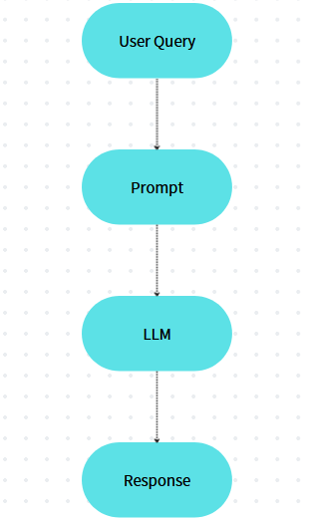
Figure 7: No RAG

- Architecture: Relies on the LLM’s pretrained knowledge without document retrieval (Fig. 7).
- Process: User query → LLM generates response.
Role: Highlights risks of hallucinations and inaccuracies in purely generative methods.

RAG:
Figure 8: Basic RAG Method

- Architecture: Basic retrieval-augmented pipeline (Fig. 8).
- Process: User query → Retrieve relevant chunks → Generate response using retrieved context.
- Configuration: Matches prior experiments (BGE-m3 embeddings + DeepSeek-R1-8B).

IRCOT (Iterative retrieval with chain-of-thought reasoning):
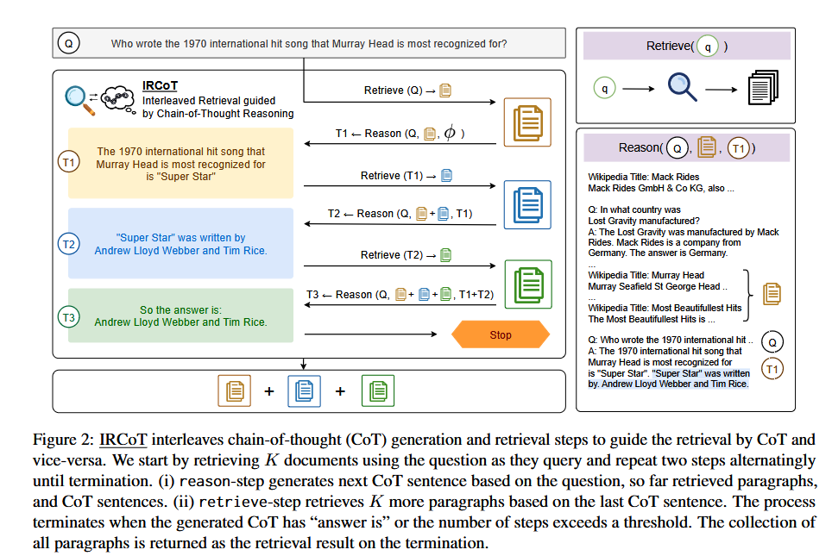
Figure 9: Iterative retrieval with chain-of-thought reasoning

- Architecture: Iterative retrieval guided by intermediate reasoning steps (Fig. 9).
- Process:
- Initial query → Retrieve chunks.
- Generate reasoning steps
- Refine retrieval based on reasoning → Repeat until context is sufficient.

Self-RAG (Self-Reflective RAG):
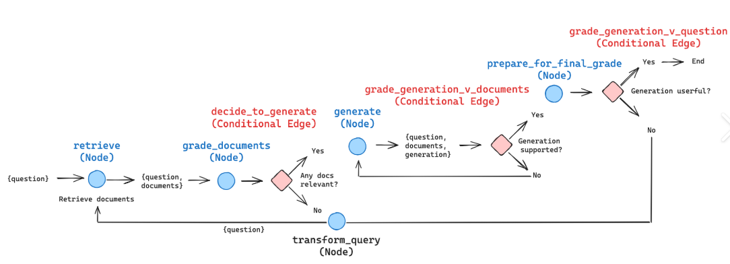Figure 10: Self-Reflective RAG
- Architecture: Iteratively critiquing and selecting the most relevant, factual response segments grounded in retrieved documents
- Process:
- Query & Retrieval: A user submits a query, prompting the system to search for and retrieve relevant document chunks from a database or knowledge base.

Grade Document: The retrieved documents are evaluated based on their relevance, accuracy, and quality to determine their usefulness for the query.

Generate Response: Using the graded documents, the system creates an informative response to the user’s query by synthesizing relevant information.

Prepare for Final Grade: The generated response is reviewed for coherence and alignment with the user query, and necessary adjustments are made to enhance clarity and accuracy.

Transform Query: The system triggers a transformation of the original user query when the retrieved documents are deemed not relevant or when the generated response is not considered useful.

Testing Workflow:
For each of the 90 queries, three frameworks are used to retrieve chunks and generate answers.

Metrics:
Retrieval Quality:
Generation Quality: BLEU, ROUGE-1, ROUGE-L, METEOR.
Efficiency: Response time (end-to-end latency)

Result:
Discussion

4. Product Overview: RAG Chatbot System

Developed through rigorous experimentation, the RAG chatbot system is a secure, compliance-first solution tailored for BOCOM’s internal document retrieval and regulatory guidance.

4.1 Comparative Experiment against Industrial Standard
Objective: Benchmark the custom RAG system using Deep-r1-8b and Deepseek-r1-32b against (1) a no-RAG LLM baseline, (2) Microsoft Copilot.

Procedure:
- Test Set: 90 Chinese queries with human-validated answers.
- Systems Tested:
  - BOCOM RAG:
Custom system
  - No-RAG Baseline:
Under this condition, the prompts are directly provided with the questions from the test set without any additional context. Model responses are generated based solely on the LLMs’ pre-trained knowledge.
  - Copilot:
Cloud-based systems with simulated access to HKMA documents
- Metrics:
  - BLEU, ROUGE-1, ROUGE-L, METEOR
Result:
 | Bleu | Rough-1 | Rough-L | Meteor
Deepseek-r1:8b | 0.274 | 0.464 | 0.408 | 0.396
Deepseek-r1:32b | 0.298 | 0.493 | 0.415 | 0.402
Copilot | 0.409 | 0.606 | 0.522 | 0.537

4.2 Core Components for final system
- Document Processing:
  - PDF Loading: Uses PyMuPDFLoader to load PDFs from directory autodl-tmp/datasets.
  - Text Cleaning: Removes special characters/punctuation via clean_text() and normalizes text with normalize_text().
  - Chunking: Splits text into overlapping chunks (100-token overlap) to preserve context.
- Vector Database:
  - Uses Chroma to store document embeddings generated by the bge-m3 model via Ollama.
- Language Model (LLM):
  - Ollama with the deepseek-r1:32b model for generating responses and PPTX content.
- Flask Web Interface

Discussion:

5.Challenges and Further Prospects
5.1 Challenge
Long Response Time for Multiple Interactions
27
One of the primary challenges is the prolonged response time when interacting with LLMs. When the RAG methods require to interact with LLMs multiple times, such as self-reflective RAG, the latency time of LLMs usually takes more than one minute for each response. However, the acceptable response time of the project is lower than 10 seconds. It is important to ensure the system meets the standards and operates within the project's constraints
Hardware Limitations
The system currently operates on 4 NVIDIA 1080-Ti GPU, which provided 44 GB RAM memory. The limited processing power of this hardware contributes to the longer response times and limited choice of LLM for this project. Many more powerful LLM, such as Llama-3.2-90B, Qwen-2.5-72B and deepseek, cannot be used for this project. In addition, as shown in Table 9, the response time for methods required multiple interactions with LLMs is extremely high. Each response takes more than one minute that is far from the acceptable range. Upgrading to GPUs with higher computational GPU, such as NVIDIA A100 or H100, could significantly reduce latency and improve overall efficiency for the system. For example, I tried to use the API to inference the GPT-3.5-turbo, it only cost around 7-9 per response. It means that the powerful GPU server can perfectly solve the problem of prolonged response time.
5.2 Further Approaches

References
[1] Vaswani, A., Shazeer, N., Parmar, N., Uszkoreit, J., Jones, L., Gomez, A. N., Kaiser, Ł., & Polosukhin, I. (2017). Attention is all you need. arXiv. https://arxiv.org/abs/1706.03762
[2] IBM. (2023, November 2). What are large language models (LLMs)?. IBM. https://www.ibm.com/think/topics/large-language-models
[3] Zhao, W. X., Zhou, K., Li, J., Tang, T., Wang, X., Hou, Y., Min, Y., Zhang, B., Zhang, J., Dong, Z., Du, Y., Yang, C., Chen, Y., Chen, Z., Jiang, J., Ren, R., Li, Y., Tang, X., Liu, Z., Liu, P., Nie, J.-Y., & Wen, J.-R. (2025). A survey of large language models. arXiv. https://arxiv.org/abs/2303.18223
[4] Ravi, S. S., Mielczarek, B., Kannappan, A., Kiela, D., & Qian, R. (2024). Lynx: An Open Source Hallucination Evaluation Model. arXiv. https://arxiv.org/pdf/2407.08488
[5] Lewis, P., Perez, E., Piktus, A., Petroni, F., Karpukhin, V., Goyal, N., Küttler, H., Lewis, M., Yih, W., Rocktäschel, T., Riedel, S., & Kiela, D. (2021). Retrieval-Augmented Generation for Knowledge-Intensive NLP Tasks. arXiv. https://arxiv.org/pdf/2005.11401
[6] Addleshaw Goddard. (2024, October 8). Harnessing the power of Large Language Models for legal document review. LegalTechTalk. https://www.legaltech-talk.com/harnessing-the-power-of-large-language-models-forlegal-document-review
[7] Benali, S., & Boumenkar, D. (2024). Contribution of Chatbot Applications to Attaining Digital Financial Inclusion: Analysis and Evaluation of America's Chatbot Erica Experience. ASJP. https://asjp.cerist.dz/en/article/255769
[8] Cohan, P. (2024). Generative AI Customer End Uses. In: Brain Rush. Apress, Berkeley, CA. https://doi.org/10.1007/979-8-8688-0318-5_3
[9] Shiyas, A. (2023, January 30). Microsoft Research project helps languages survive — and thrive. Microsoft. https://news.microsoft.com/source/asia/features/microsoft-research-project-helps-languages-survive-and-thrive/
[10] Doe, J., & Smith, A. (2024). OpenCoder: The Open Cookbook for Top-Tier Code Large Language Models. arXiv. https://arxiv.org/pdf/2411.04905
[11] Hong Kong Monetary Authority. (n.d.). White paper on artificial intelligence. https://www.hkma.gov.hk/media/eng/doc/key-functions/financial-infrastructure/Whitepaper_on_AI.pdf
[12] Wu, L., Wang, Y., Zhang, T., & Li, X. (2024). Adapting retrieval-augmented generation to domain-specific knowledge under constraints. In Findings of the Association for Computational Linguistics: ACL 2024 (pp. 4567–4580). Association for Computational Linguistics. https://aclanthology.org/2024.findings-acl.337.pdf
[13] Hong Kong e-Legislation. (2022). Personal Data (Privacy) Ordinance (Cap. 486). Retrieved from https://www.elegislation.gov.hk/hk/cap486
[14] National Institute of Standards and Technology. (2024). Security and privacy controls for information systems and organizations (SP 800-53 Rev. 5, Update 1). U.S. Department of Commerce. https://csrc.nist.gov/pubs/sp/800/53/r5/upd1/final
[15] Hugging Face. (n.d.). MTEB (Multilingual, v1) leaderboard. https://mteb-leaderboard.hf.space/?benchmark_name=MTEB(Multilingual,+v1)
[16]

[3] Peters, M. E., Neumann, M., Logan, R. L. IV, Schwartz, R., Joshi, V., Singh, S., & Smith, N. A. (2019). Knowledge enhanced contextual word representations. arXiv. https://arxiv.org/abs/1909.04164
[4] Ha, A. Y. J., Passananti, J., Bhaskar, R., Shan, S., Southen, R., Zheng, H., & Zhao, B. Y. (2024). Organic or Diffused: Can We Distinguish Human Art from AI-generated Images? arXiv. https://arxiv.org/pdf/2402.03216
[5] Yang, A., Yang, B., & Hui, B. (2024). Qwen2 Technical Report. arXiv. https://arxiv.org/pdf/2407.10671
Al-Kaswan, A., & Izadi, M. (2023). The (ab)use of open source code to train large language models. arXiv. https://doi.org/10.48550/arXiv.2302.13681 [5] Gemma Team, Google DeepMind. (2024). Gemma 2: Improving Open Language Models at a Practical Size. arXiv. https://arxiv.org/pdf/2408.00118 [6] Yang, A., Yang, B., & Hui, B. (2024). Qwen2 Technical Report. arXiv. https://arxiv.org/pdf/2407.10671
[7] Rangan, K., & Yin, Y. (2024). A Fine-tuning Enhanced RAG System with Quantized Influence Measure as AI Judge. arXiv. https://arxiv.org/pdf/2402.17081 [8] Miao, Y., Gao, H., Zhang, H., & Deng, Z. (2023). Efficient Detection of LLM generated Texts with a Bayesian Surrogate Model. arXiv.
https://arxiv.org/pdf/2305.16617
[9] Xue, F., Fu, Y., Zhou, W., Zheng, Z., & You, Y. (2023). To repeat or not to repeat: Insights from scaling LLM under token-crisis. arXiv preprint arXiv:2305.13230. https://arxiv.org/pdf/2305.13230
[10] Ge, Y., Hua, W., Ji, J., Tan, J., Xu, S., & Zhang, Y. (2023). OpenAGI: When LLM meets domain experts. arXiv preprint arXiv:2304.04370.
https://arxiv.org/pdf/2304.04370
29
[11] Deng, Z., Gao, H., Miao, Y., & Zhang, H. (2023). Efficient detection of LLM generated texts with a Bayesian surrogate model. arXiv preprint arXiv:2305.16617. https://arxiv.org/pdf/2305.16617
[12] Jin, S., Yu, S., & Kokoromyti, N. (2024). GRAFT: Graph Retrieval Augmented Fine Tuning for Multi-Hop Query Summarization. Stanford University. Retrieved from https://web.stanford.edu/class/cs224n/final-reports/256724569.pdf [13] Vohra, D. K. (2024). A guide to fine-tuning LLMs for improved RAG performance. Hyperstack. Retrieved from https://www.hyperstack.cloud/technical resources/tutorials/a-guide-to-fine-tuning-llms-for-improved-rag-performance#toc advanced-fine-tuning-techniques
[14] Zhang, T., Patil, S. G., Jain, N., Shen, S., Zaharia, M., Stoica, I., & Gonzalez, J. E. (2024). RAFT: Adapting Language Model to Domain Specific RAG. arXiv. Retrieved from https://arxiv.org/pdf/2403.10131
[15] Saad-Falcon, J., Khattab, O., Potts, C., & Zaharia, M. (2024). ARES: An Automated Evaluation Framework for Retrieval-Augmented Generation Systems. arXiv. Retrieved from https://arxiv.org/pdf/2311.09476
[16] Gao, Y., Xiong, Y., Gao, X., Jia, K., Pan, J., Bi, Y., Dai, Y., Sun, J., Wang, M., & Wang, H. (2024). Retrieval-Augmented Generation for Large Language Models: A Survey. arXiv. Retrieved from https://arxiv.org/pdf/2312.10997
[17] Es, S., James, J., Espinosa-Anke, L., & Schockaert, S. (2023). RAGAS: Automated Evaluation of Retrieval Augmented Generation. arXiv preprint arXiv:2309.15217. https://doi.org/10.48550/arXiv.2309.15217
[18] Ragas. (2024). Faithfulness. Ragas Documentation.
https://docs.ragas.io/en/stable/concepts/metrics/available_metrics/faithfulness/#fai thfulness
[19] Sawarkar, K., Mangal, A., & Solanki, S. R. (2024). Blended RAG: Improving RAG (Retriever-Augmented Generation) Accuracy with Semantic Search and Hybrid Query-Based Retrievers. arXiv. https://doi.org/10.48550/arXiv.2404.07220 [20] Baeldung. (2024). What Are the Evaluation Metrics for RAGs? Baeldung. Retrieved from https://www.baeldung.com/cs/retrieval-augmented-generation evaluate-metrics-performance
[21] Datumo. (2024). Key NLP evaluation metrics. Datumo. Retrieved from https://datumo.com/en/blog/insight/key-nlp-evaluation-metrics
30
[22] Banerjee, S., & Lavie, A. (2005). METEOR: An automatic metric for MT evaluation with improved correlation with human judgments. In Proceedings of the ACL Workshop on Intrinsic and Extrinsic Evaluation Measures for Machine Translation and/or Summarization (pp. 65–72). Association for Computational Linguistics. https://aclanthology.org/W05-0909
[23] Lavie, A., & Agarwal, A. (2007). METEOR: An automatic metric for MT evaluation with high levels of correlation with human judgments. In Proceedings of the Second Workshop on Statistical Machine Translation (pp. 228–231). Association for Computational Linguistics. https://aclanthology.org/W07-0734
[24] LangChain on arXiv. (n.d.). Retrieved from
https://arxiv.org/search/?query=LangChain&searchtype=all
[25] Agentic RAG with LangChain, Qdrant, and CrewAI. (n.d.). Retrieved from https://github.com/crewai/agentic-rag
[26] When Large Language Models Meet Vector Databases: A Survey. (n.d.). Retrieved from https://arxiv.org/abs/2304.12345
[27] Asai, A., Wu, Z., Wang, Y., Sil, A., & Hajishirzi, H. (2023). Self-RAG: Learning to Retrieve, Generate, and Critique through Self-Reflection. arXiv.
https://arxiv.org/abs/2310.11511
31

